Scientific Method: 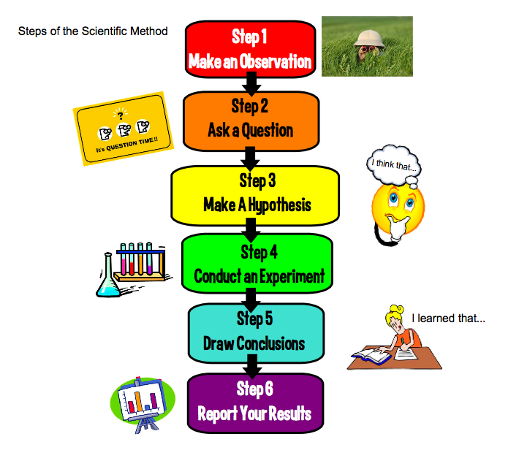

O = observation

A = Ask a question

H = Hypothesis

E = Experiment

C = Conclusion

